VEX Robotics Competition and the P.O.T.A.T.O.E.S. Robotics Club

*What is the VEX Robotics Competition?*

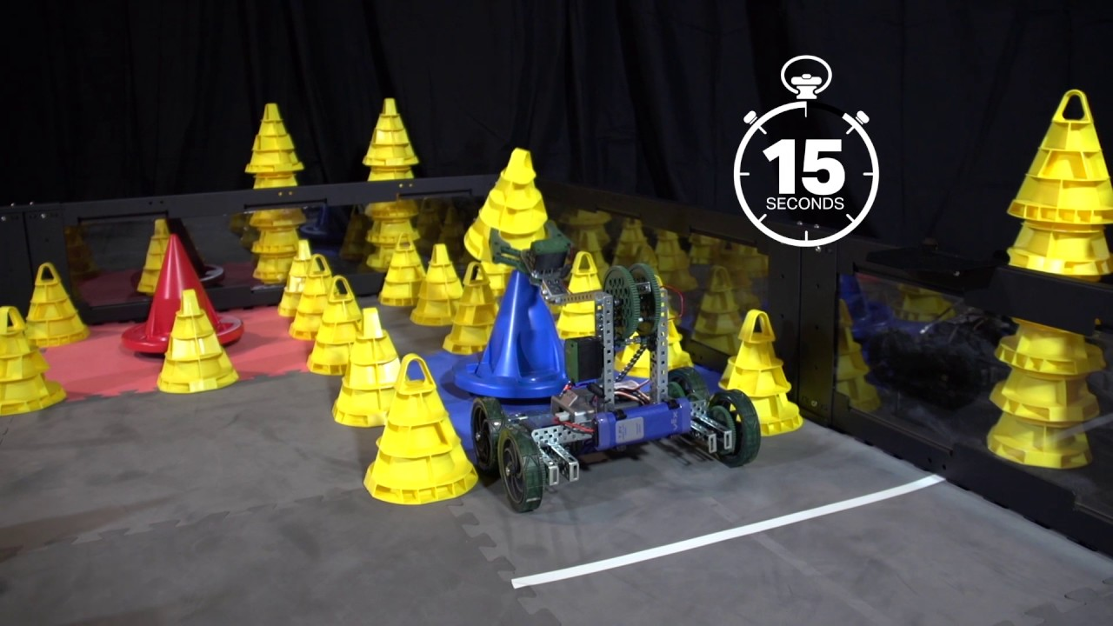The VEX Robotics Competition is a competition in which teams build robots to complete a specific task. This ‘task’ can include throwing balls, stacking cones, or moving cubes. Building a robot is not an easy task. To create a VEX robot, teams need to learn how to program, use team communication, and combine VEX parts.

*How do I build a VEX Robot?*

Building a VEX robot is not a simple process that can be learned in one day; it requires learning over the course of many days. In the P.O.T.A.T.O.E.S. Robotics Club, students learn how to build a VEX Robot by combining a variety of skills and disciplines. For example, students learn how to use the design process to brainstorm, fabricate, and evaluate their solutions to certain problems. Team members incorporate many different skills in the design process, which may include programming, 3D modeling, building, marketing, and video editing.

The 2017-2018 VEX Robotics Competition is called “In the Zone”. In this year’s competition, students must build a robot that stacks cones on top of each other.

*How do I Sign Up?*

To sign up, attend the first Robotics Meeting on September 7, Thursday. Meeting usually last between 4:00 PM to 7:00 PM. At the first meeting, you will receive the sign up slip in addition to important documents that individuals may find useful.

*El Segundo High School Robotics Club!*

The El Segundo High School Robotics Club gives students opportunities to incorporate S.T.E.M. activities in their interests. For example, students who have an interest in media or business are able to demonstrate their interests in the respective subgroups of the Robotics Club. Club members can join other activities besides the VEX Competition, which include but are not limited to the: Learn Programming Club, CyberPatriots, The Drone Club, and E.S.C.E.I.

VEX Robotics Competition and the P.O.T.A.T.O.E.S. Robotics Club

*What is the VEX Robotics Competition?*

The VEX Robotics Competition is a competition in which teams build robots to complete a specific task. This ‘task’ can include throwing balls, stacking cones, or moving cubes. Building a robot is not an easy task. To create a VEX robot, teams need to learn how to program, use team communication, and combine VEX parts.

*How do I build a VEX Robot?*

Building a VEX robot is not a simple process that can be learned in one day; it requires learning over the course of many days. In the P.O.T.A.T.O.E.S. Robotics Club, students learn how to build a VEX Robot by combining a variety of skills and disciplines. For example, students learn how to use the design process to brainstorm, fabricate, and evaluate their solutions to certain problems. Team members incorporate many different skills in the design process, which may include programming, 3D modeling, building, marketing, and video editing.

The 2017-2018 VEX Robotics Competition is called “In the Zone”. In this year’s competition, students must build a robot that stacks cones on top of each other.

*How do I Sign Up?*

To sign up, attend the first Robotics Meeting on October 12 Thursday. Meeting usually last between 4:00 PM to 7:00 PM. At the first meeting, you will receive the sign up slip in addition to important documents that individuals may find useful.

*El Segundo High School Robotics Club!*

The El Segundo High School Robotics Club gives students opportunities to incorporate S.T.E.M. activities in their interests. For example, students who have an interest in media or business are able to demonstrate their interests in the respective subgroups of the Robotics Club. Club members can join other activities besides the VEX Competition, which include but are not limited to the: Learn Programming Club, CyberPatriots, The Drone Club, and E.S.C.E.I.